(Small-town Police) During each four-hour period, the Small-town police force requires the following number of on-duty police officers: four from midnight to 4 a.m.; four from 4 a.m. to 8 a.m.; seven from 8 a.m. to noon; seven from noon to 4 p.m.; eight from 4 p.m. to 8 p.m.; and ten from 8 p.m. to midnight. Each police officer works two consecutive four-hour shifts. Determine how to minimize the number of police officers needed to meet Small town’s daily requirements.

**Discussion: -**

Our Objective is to develop an LP model that relates six shift schedules to daily number of police officers available, and to use Solver on this model to find a schedule that uses the fewest number of officers and meets all daily workforce requirements. Please look at below given picture which helps us in identifying the decision variable.

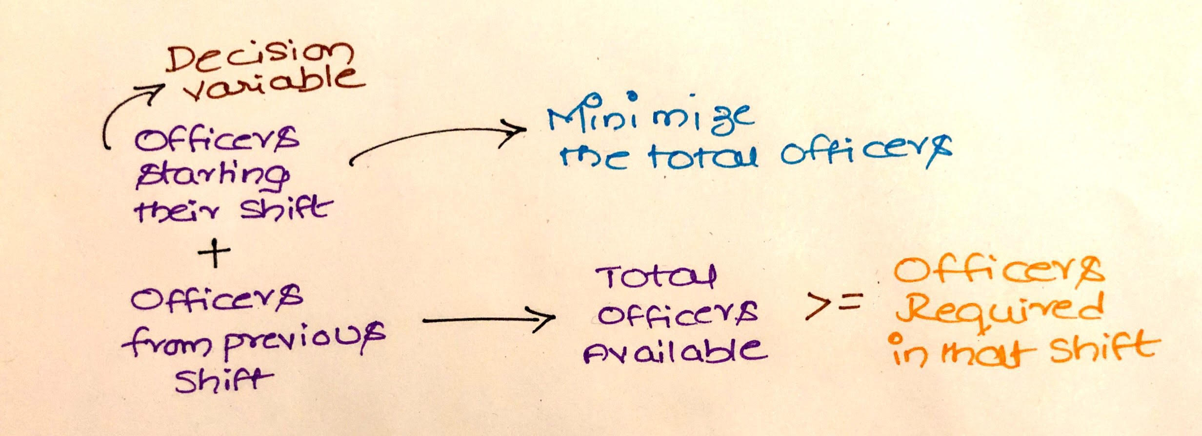

Our objective is to minimize the total number of officers. By looking at the problem, we understand that we need to schedule officers for six shifts. In the problem, we can see that there is a condition that an officer who starts work will continue doing two continuous shifts. Assume if you know the officers starting their work in particular shift, will you be able to solve the problem? Yes, we can solve the problem. Now please look at the picture given, we have decided our decision variable, now we need to calculate the officers who started their work in previous shift also will continue doing their job in this shift. We have solved similar problem earlier by creating information table which helps us in finding this value. Please check mathematical model for information table.

**Mathematical Model: -**

*Parameters (Inputs):*

|  |  |  |  |  |  |  |
| --- | --- | --- | --- | --- | --- | --- |
| **Information Table** | 12 AM to 4 AM | 4 AM to 8 AM | 8 AM to 12 PM | 12 PM to 4 PM | 4 PM to 8 PM | 8 PM to 12 AM |
| 12 AM to 4 AM | 1 | 1 | 0 | 0 | 0 | 0 |
| 4 AM to 8 AM | 0 | 1 | 1 | 0 | 0 | 0 |
| 8 AM to 12 PM | 0 | 0 | 1 | 1 | 0 | 0 |
| 12 PM to 4 PM | 0 | 0 | 0 | 1 | 1 | 0 |
| 4 PM to 8 PM | 0 | 0 | 0 | 0 | 1 | 1 |
| 8 PM to 12 AM | 1 | 0 | 0 | 0 | 0 | 1 |

*Decision Variables:*

*Calculated Variables:*

*Objective:*

*Constraints:*

As it is minimizing the number of officers, we must make sure that we give non-negative constraint to the decision variable. Number of officers available in shift ‘j’ should be always greater than the on-duty officers demand which is given in our problem.

*Excel Implementation:*

Please find the attached spreadsheet for solution.

